**ASSIGNMENT 4**

|  |  |
| --- | --- |
| Date | 01 Nov 22 |
| Name | SURUTHI.R |
| Team Id | PNT2022TMID30465 |
| Assignment | Four |

Write code and connections in wokwi for ultrasonic sensor.

Whenever distance is less than 100 cms send "alert" to ibm cloud and display in device recent events.

Upload document with wokwi share link and images of ibm cloud

**CODE:**

|  |
| --- |
| #include <WiFi.h>  #include <PubSubClient.h> WiFiClient wifiClient;    #define ORG "nhpwjc"  #define DEVICE_TYPE "NodeMCU"  #define DEVICE_ID "USE YOUR ID"  #define TOKEN "USE YOUR TOKEN"  #define speed 0.034 char server[] =  ORG  ".messaging.internetofthings.ibmcloud.com"; char publishTopic[]  = "iot-2/evt/Data/fmt/json"; char topic[] = "iot-  2/cmd/home/fmt/String"; char authMethod[] = "use-tokenauth"; char token[] = TOKEN;  char clientId[] = "d:" ORG ":" DEVICE_TYPE ":" DEVICE_ID;  PubSubClient client(server, 1883, wifiClient); void publishData(); const int trigpin=5;  const int echopin=18;  String command;  String data=""; long  duration; float dist;    void  setup()  {  **Serial**.begin(115200); pinMode(trigpin, OUTPUT); |

|  |
| --- |
| pinMode(echopin, INPUT); wifiConnect(); mqttConnect();  } void loop() { publishData(); delay(500);  if (!client.loop()) { mqttConnect(); }  }  void wifiConnect() {  **Serial**.print("Connecting to "); **Serial**.print("Wifi");  WiFi.begin("Wokwi-GUEST", "", 6); while (WiFi.status() !=  WL_CONNECTED) { delay(500); **Serial**.print("."); }  **Serial**.print("WiFi connected, IP address: "); **Serial**.println(WiFi.localIP());  }  void mqttConnect() { if  (!client.connected()) {  **Serial**.print("Reconnecting MQTT client to "); **Serial**.println(server); while  (!client.connect(clientId, authMethod, token)) { **Serial**.print("."); delay(500); } initManagedDevice(); **Serial**.println(); } }  void initManagedDevice() { if  (client.subscribe(topic)) {  // Serial.println(client.subscribe(topic)); **Serial**.println("subscribe to cmd OK");  } else {  **Serial**.println("subscribe to cmd FAILED"); } } void publishData()  { digitalWrite(trigpin,LOW); digitalWrite(trigpin,HIGH); |
| delayMicroseconds(10); digitalWrite(trigpin,LOW); duration=pulseIn(echopin,HIGH); dist=duration*speed/2; if(dist<100){ String payload = "{\"Alert distance\":"; payload += dist; payload += "}";  **Serial**.print("\n");  **Serial**.print("Sending payload: "); **Serial**.println(payload); if (client.publish(publishTopic, (char*) payload.c_str())) { **Serial**.println("Publish OK");  } else {  **Serial**.println("Publish FAILED"); }  }  } |

**CONNECTIONS:**

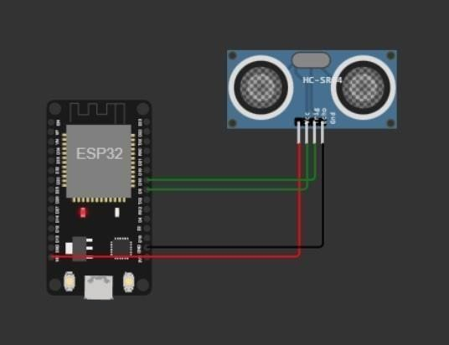

**OUTPUT:**

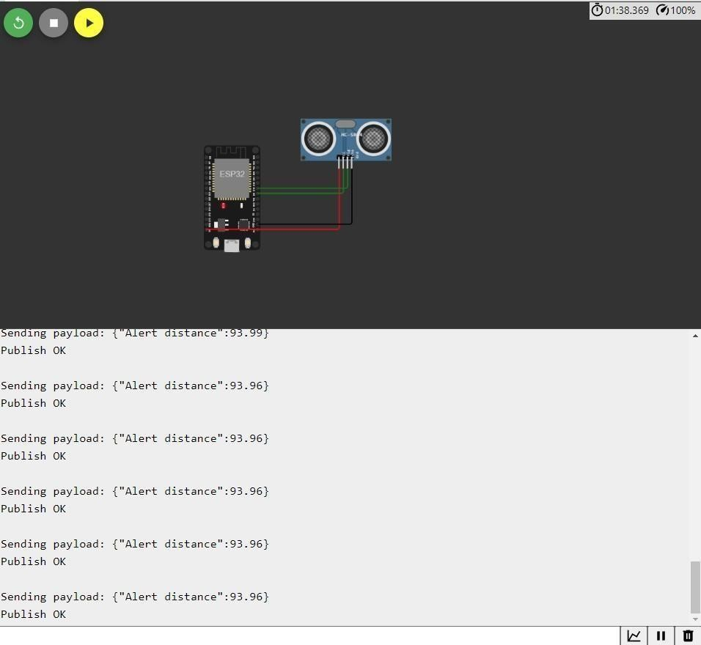

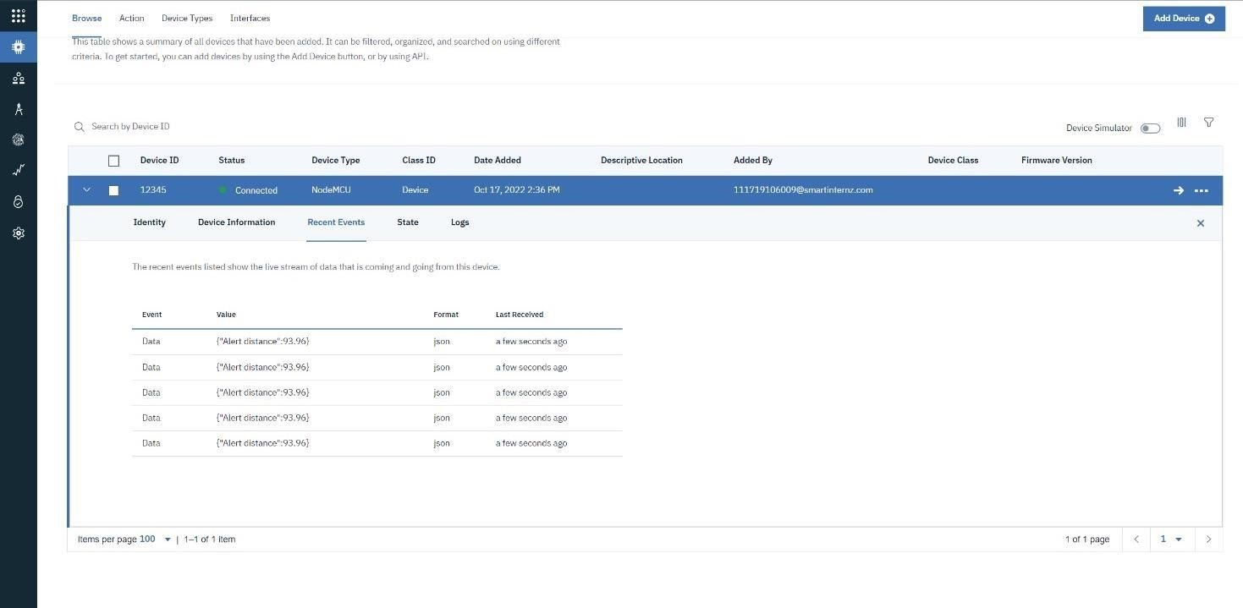

**WOKWI LINK -**

[**https://wokwi.com/projects/346405970317935188**](https://wokwi.com/projects/346405970317935188)